Instructions to Access Chamberlain University
Human Subjects Research Course Provided by CITI

New Users:
Step 1: Log into https://www.citiprogram.org
Step 2: If a new user, click on the “Register” tab
Step 3: Go to the “To find your organization….” Tab and type in Chamberlain University:

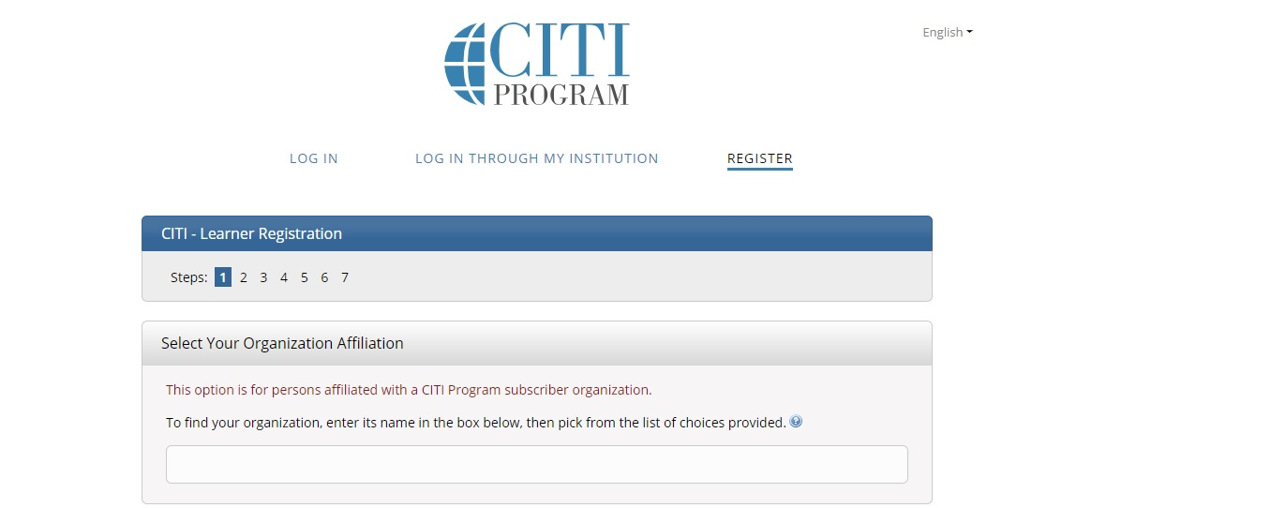

Step 4: Check the box marked “I agree to Terms of Service…..” and “I affirm that I am an affiliate of Chamberlain University” (This will allow you to enroll in the Chamberlain course at no charge..) Then click “Continue”
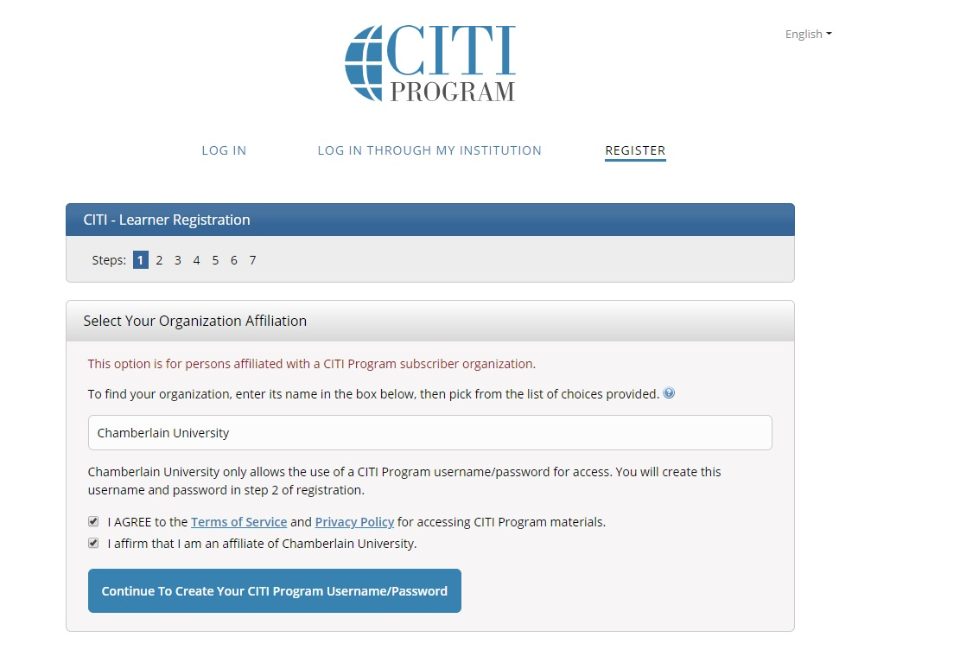
Step 5: Type in your personal information into the Learner Registration page, then click the “Continue” tab at the bottom of the page.

Step 6: Fill in the information to create a user name and password, then click the “Continue” tab at the bottom of the page.

Step 7: Type in your country of residence, then click the “Continue” tab at the bottom of the page.

Step 8: Indicate whether or not you wish to obtain CE credits for the course. Please note: If you say “Yes”, you will be charged a fee. Please indicate whether or not CITI may contact you for surveys or marketing information, then click “Continue” at the bottom of the page.

Step 9: Please complete the Learner Registration Information. For Chamberlain students and employees, please type in your D number for “Employee Number”, otherwise, please leave blank.
For “Role in Research”, you may have several roles. Please select just one. Students should always select “Student Researcher” and the appropriate level. Then click “Continue” at the bottom of the page.

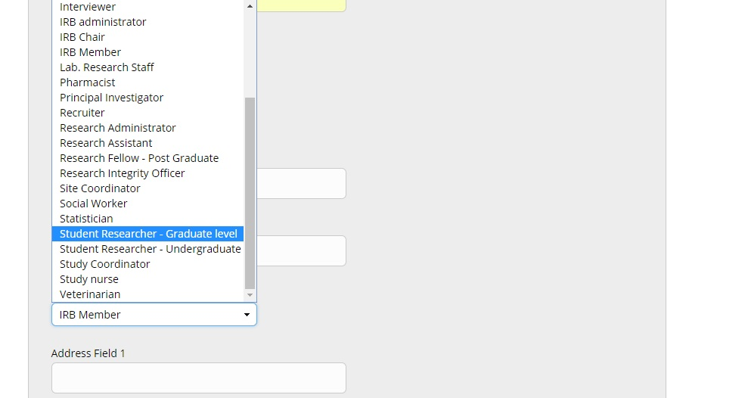
Step 10: Select the Human Subjects Research course you wish to take in the field titled “Question 1”. Students should select the Biomedical Research Investigators course. For others, select the course that best fits the type of research you will be engaged with. This question requests one answer only; however, you can always add another course later.
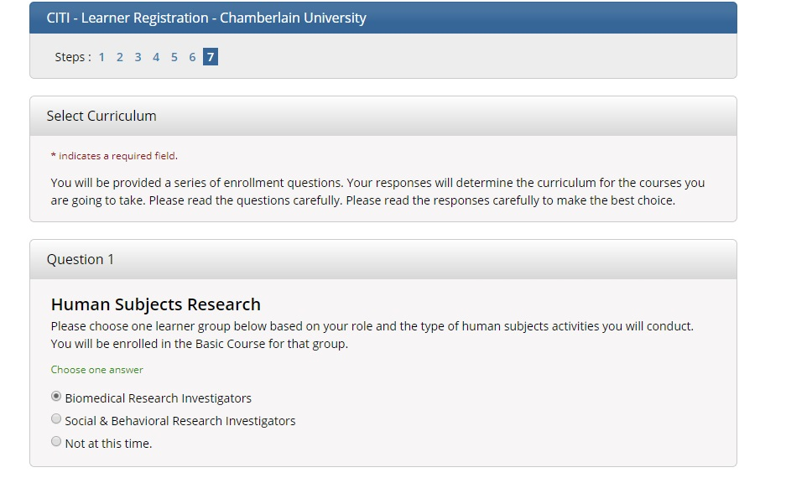

Step 11: Click on the check box under “Important Notice”. This indicates that you are aware that courses purchased as an independent learner are not provided by Chamberlain. Then click the “Complete Registration” tab.
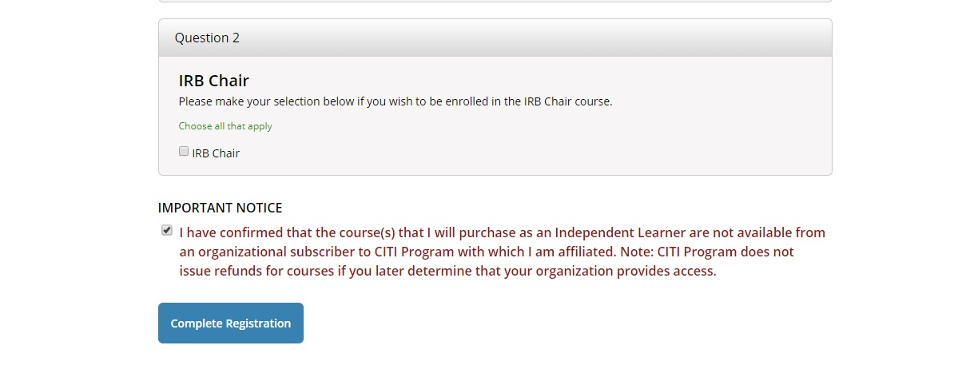

Step 12: Click the “Finalize Registration” tab.
Step 13: You can now access your course. Click on the “Chamberlain University Courses” tab to pull up a drop-down menu. You should see your course as well as some additional actions. To access the course, click on the title of your course.
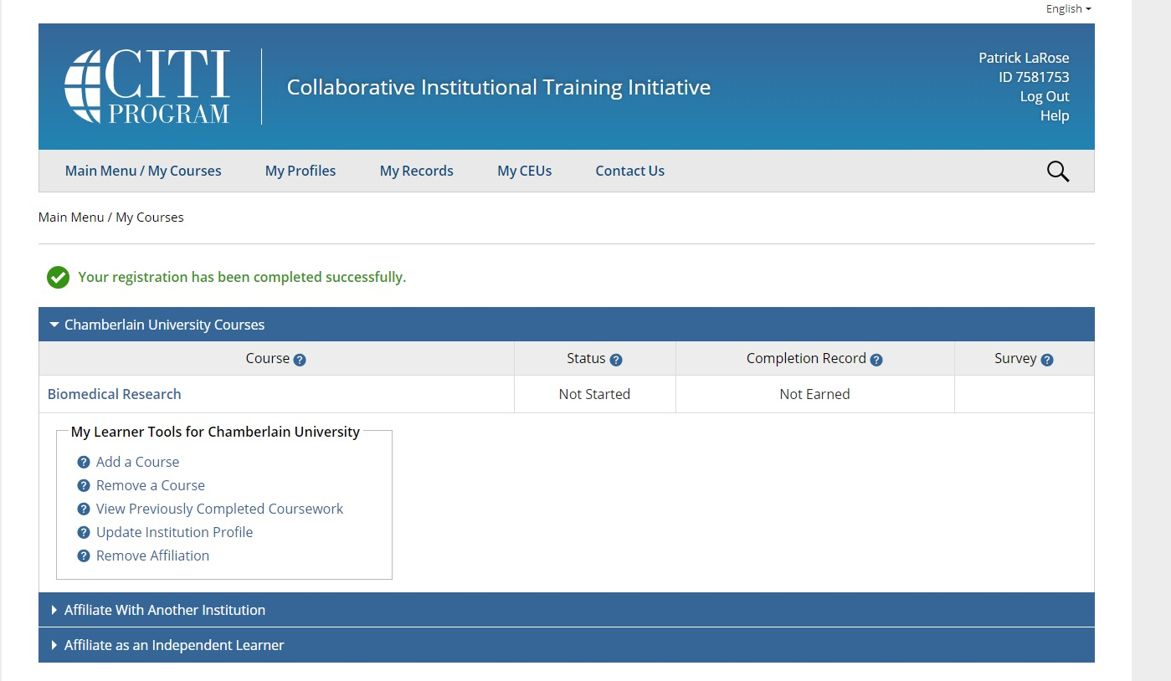
Step 14: After you have clicked on the link to your course, you will be asked to complete an assurance of integrity statement. Click on the “Complete The Integrity Assurance Statement….” Tab. Click on :”Agree” and then “Submit”.
Step 15: The modules for your course will now appear and be accessible. The course requires that you complete the modules in a certain sequence. The modules available for access will be in blue font as a hyperlink. When you complete a module, at the bottom of the page, you will be asked to complete the quiz. You must earn an 80% on all modules to successfully complete the course. You will be able to print up a transcript and certificate upon completion of the course.

Existing Users
Step 1: Access CITI at https://www.citiprogram.org and login using your existing username and password.
Step 2: Click on “My Profiles” to update any new information.
Step 2: Continue with Step #13 above.

